INFO B-581 SPRING 2024

PROJECT SPRINT 3
GROUP 5
THE SAVVY HEALTH SQUAD
Deepishka Pemmasani
Harika Mareddy
Meghana Darla
Priyankitha Kandi

Department of Biohealth Informatics
Luddy School of Informatics, Computing, and Engineering
IUPUI
Dr. Saptarshi Purkayastha
April 02, 2024

CDA View of patient chart summary:

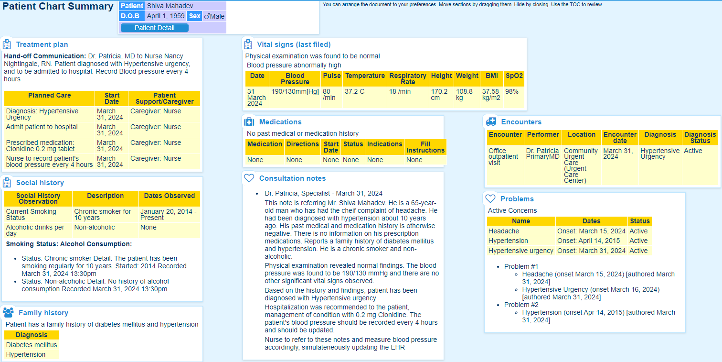
The above CDA can be viewed with the link: https://backbeachsoftware.com.au/challenge/index.htm
Patient demographics section:
Active Problems:
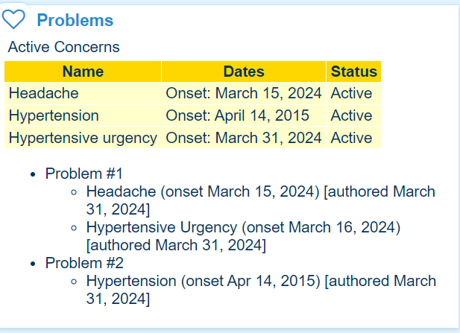

Social History:
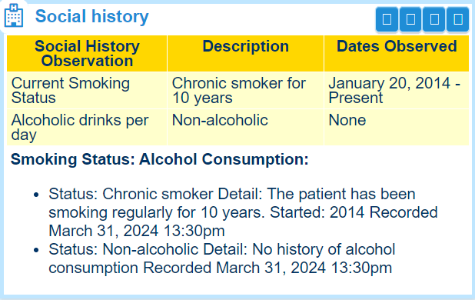
Family History:
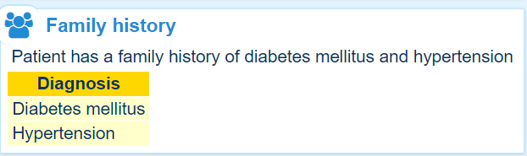
Vital Signs:
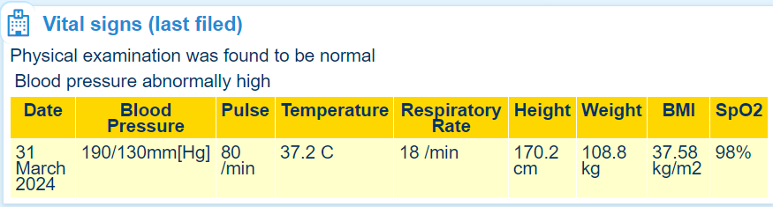

Patient Encounter:
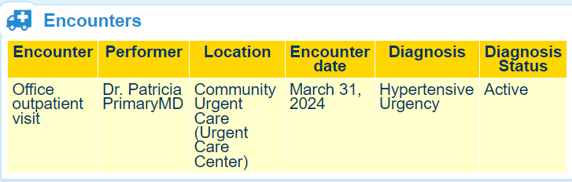
Past medical and medication history:
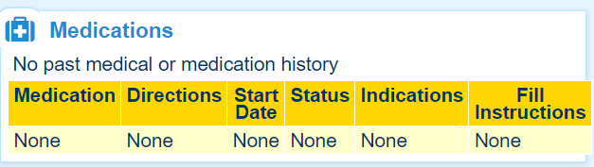
Consultation Notes:
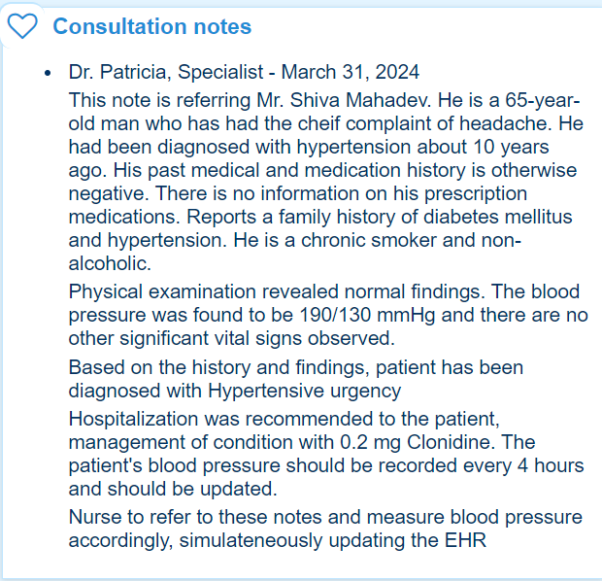
Treatment Plan:
